Occlusion Shadow

📘 Definition
# Source: AI Source: Provided by: [Data Path: Persons Table -> ID Column: 1, Name_En Column: Motasem Essam] -> From: [ChatGPT] on [5/2/2026]
An Occlusion Shadow (often called Ambient Occlusion) is a very dark shadow that appears in small, tight areas where light cannot reach easily.
It usually forms where objects touch each other or in corners and creases.

🌑 How occlusion shadow forms
# Source: AI Source: Provided by: [Data Path: Persons Table -> ID Column: 1, Name_En Column: Motasem Essam] -> From: [ChatGPT] on [5/2/2026]
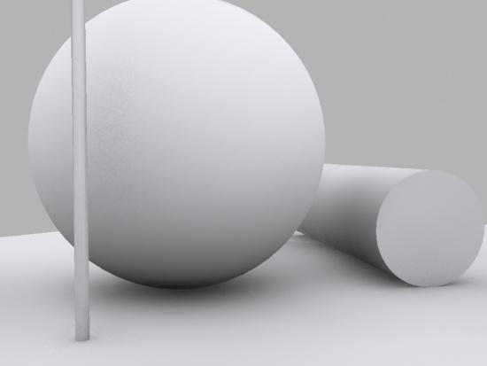
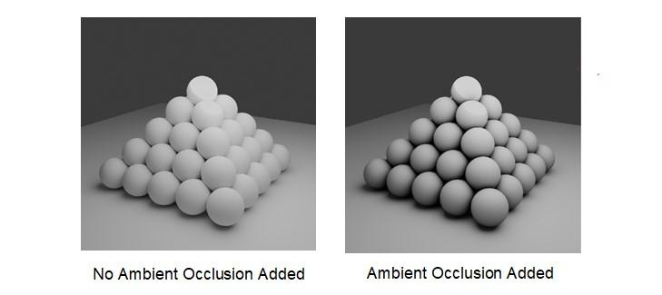
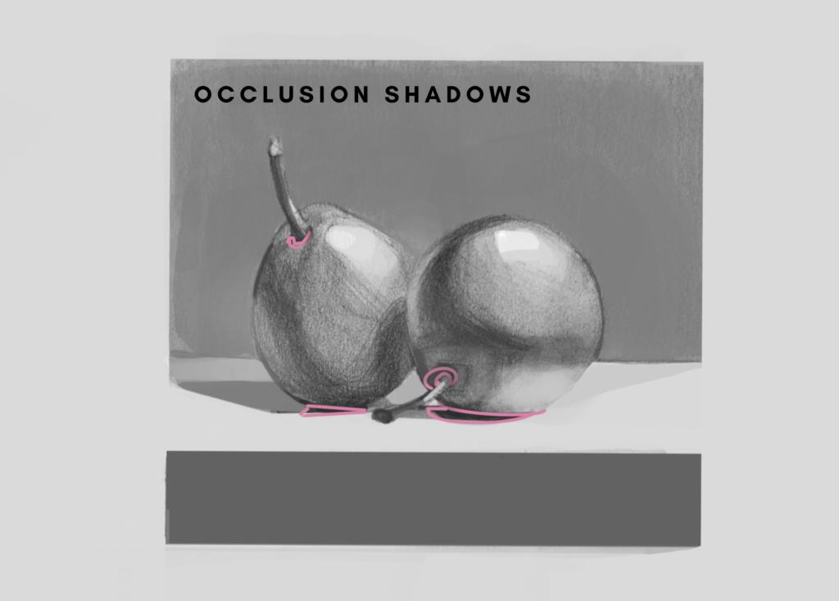
- Light is blocked from many directions
- Very little or no light reaches the area
- The result is a small, very dark shadow

🧠 Simple example
# Source: AI Source: Provided by: [Data Path: Persons Table -> ID Column: 1, Name_En Column: Motasem Essam] -> From: [ChatGPT] on [5/2/2026]
Think of:
- 📦 The corner of a room → darker than the walls
- ☕ The bottom of a cup touching a table → dark ring
- 📚 Between stacked books → small dark gaps

🎮 In computer graphics
# Source: AI Source: Provided by: [Data Path: Persons Table -> ID Column: 1, Name_En Column: Motasem Essam] -> From: [ChatGPT] on [5/2/2026]
Occlusion shadows are used to:
- Add realism and depth
- Show contact between objects
- Improve detail in corners and edges

⚙️ Key features
# Source: AI Source: Provided by: [Data Path: Persons Table -> ID Column: 1, Name_En Column: Motasem Essam] -> From: [ChatGPT] on [5/2/2026]
- 🌑 Very dark and subtle
- 📍 Found in corners, gaps, and contact areas
- 🎯 Does not depend on a single light source
- 🧩 Enhances realism

🚀 In short:
# Source: AI Source: Provided by: [Data Path: Persons Table -> ID Column: 1, Name_En Column: Motasem Essam] -> From: [ChatGPT] on [5/2/2026]
Occlusion Shadow = a small, dark shadow in tight spaces where light cannot reach, adding realism and depth.

